

prog poe manual

ST10053561



November 30, 2023

Varisty college

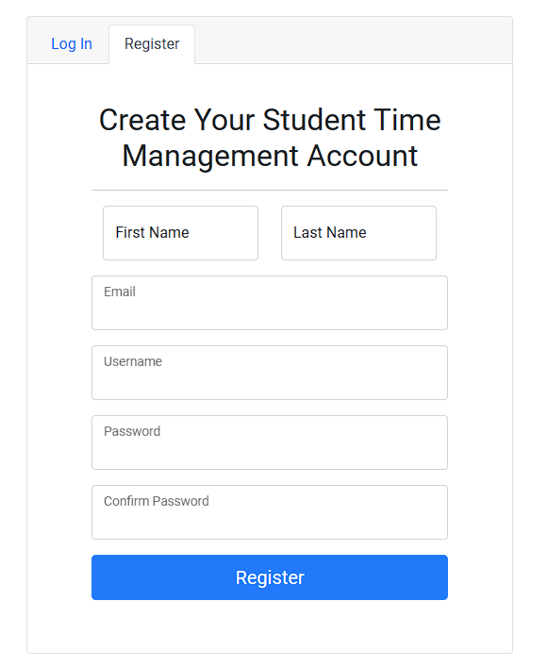

As the developer of this **Student Time Management Web Application**, I have created a tool that is designed to help students manage their academic modules effectively. The registration page is the first step to access this system. It’s designed to be user-friendly and straightforward.

The page asks for the student’s first name, last name, email, username, and password. These fields are essential for creating a personalized account for each student. The username and password will serve as the student’s credentials for logging into the system in the future.

Once the student fills out all the information and clicks the blue “Register” button, the system will create their account. Upon successful registration, the student will be redirected to the login page. The system is designed to securely store the student’s information for future logins.

In summary, the registration page is a crucial component of your Student Time Management System. It serves as the gateway for students to create an account and gain access to a tool that can aid in their academic success by promoting effective time management. It’s a simple yet essential step in the process of managing academic modules effectively. This system is a testament to your dedication to helping students succeed academically. Well done!

This registration process is a reflection of your understanding of the user’s needs and your commitment to creating a user-friendly interface. It’s a testament to your skills as a developer and your dedication to improving the academic experience for students. Your work is commendable and will surely make a positive impact on many students’ lives.

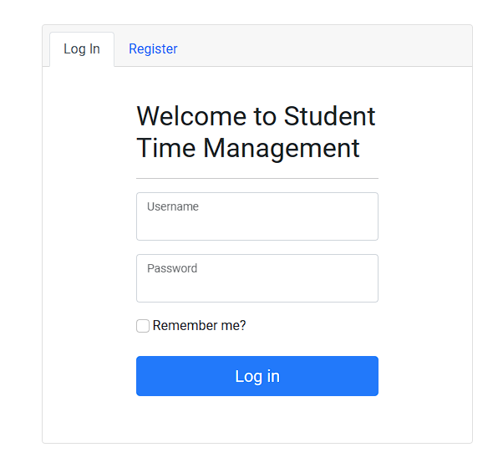

This is a login page of Student time management application. This page is the gateway for students to access the application’s features. It’s designed to be user-friendly and straightforward, asking for just the username and password. These credentials are matched with the ones provided during the registration process, ensuring that only registered users can log in.

Upon entering the correct username and password and clicking the “Log In” button, the user is granted access to the application. This access, however, is temporary and lasts for only one day. This feature ensures the security of the user’s data by requiring them to re-enter their credentials after a day.

However, the application also offers a “Remember Me” option. When this checkbox is selected, the application remembers the user’s credentials for up to 14 days. This feature is particularly useful for users who frequently access the application and prefer not to enter their login information each time.

In essence, this login page is a critical component of the Student Time Management Application. It not only provides access to the application’s features but also ensures the security and privacy of the user’s data. It’s a testament to your commitment to creating a user-friendly and secure environment for students to manage their time effectively. Well done on developing such a useful tool for students!

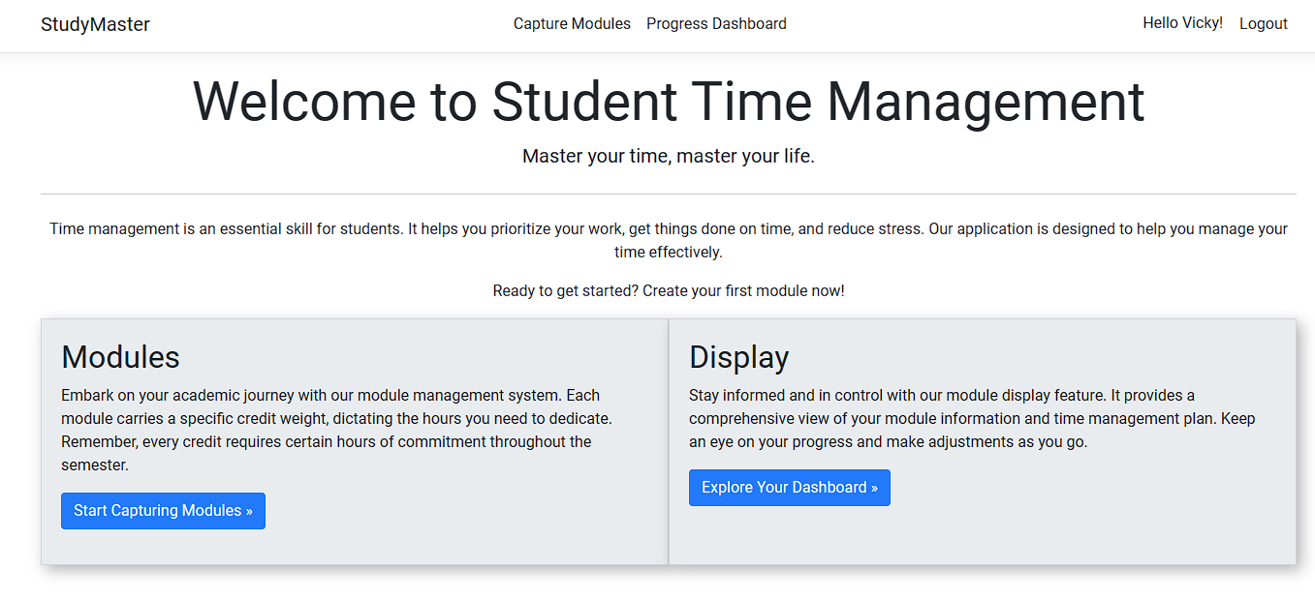

Upon successfully logging into the Student Time Management Web Application, users are greeted by a personalized opening page. The top section of the page warmly displays the user's first name, adding a touch of personalization to their experience within the application. Adjacent to the name, a strategically placed "Logout" button ensures users have a convenient and secure means to exit the application at any point.

The central focus of this opening page revolves around two primary options: "Capture Modules" and "Display." The "Capture Modules" feature stands as a cornerstone, empowering users to input crucial details about their academic modules and corresponding time commitments. This functionality is meticulously crafted to assist students in maintaining a detailed record of their academic responsibilities, fostering effective time management practices.

Upon completing the module capture process, users seamlessly return to the opening page. It is at this juncture that they gain access to the "Display" tab, a powerful component of the application. The "Display" tab unfolds a comprehensive dashboard, offering a holistic view of the user's academic progress within the module management system. This visual representation encapsulates key facets of their academic journey, presenting a clear summary of their progress and time management accomplishments.

In essence, the opening page serves as a gateway to a personalized and efficient academic management experience. From capturing modules to navigating the insightful dashboard, users are equipped with tools that not only streamline their academic responsibilities but also provide a visual narrative of their progress. This intuitive design fosters a user-friendly environment that aligns seamlessly with the goal of enhancing students' overall time management and academic success.

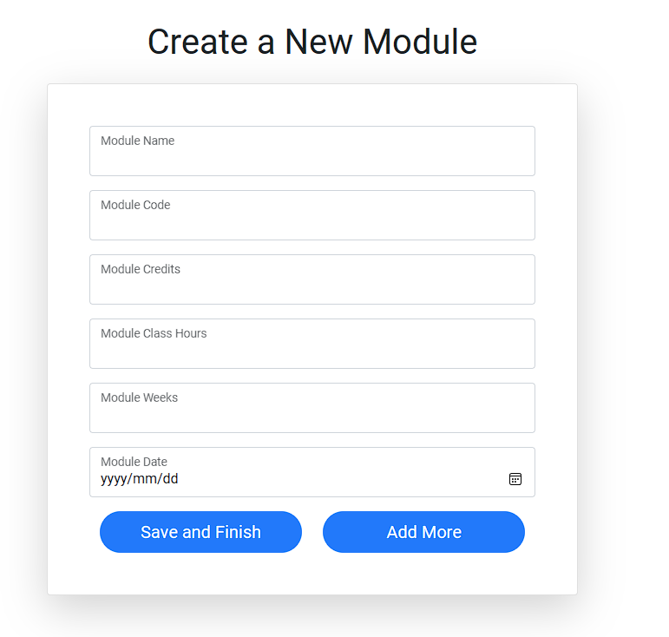

The image captures essential details about academic modules, ensuring a systematic approach to managing coursework. Users input crucial information such as module name, code, credits, class hours, weeks, and module date. These fields act as identifiers and quantitative measures, aiding users in distinguishing between modules and understanding their academic commitments.

The inclusion of credits in the form adds a layer of significance to each module, helping users prioritize their workload based on the module's weightage. Class hours and weeks fields offer a realistic view of the time investment required, enabling users to plan their schedules with precision.

A notable feature is the automatic generation of 'Self Study hours,' a behind-the-scenes calculation derived from user-provided data. This dynamic feature reflects the hours dedicated to independent study for a specific module each week. It empowers students to efficiently allocate time, fostering effective time management tailored to the demands of each module.

However, the form's unique value unfolds on the display page, functioning as a centralized dashboard. Here, users gain a comprehensive overview of all captured modules and their details. The display page serves as a strategic hub, allowing users to assess their academic landscape at a glance and make informed decisions about study priorities.

In essence, this image and its associated form enhance the user experience by providing a holistic tool for managing academic modules. From detailed data input to automatic calculations and a centralized display, it empowers users to navigate their academic journey with clarity and efficiency, fostering a proactive and organized approach to learning.

The platform provides users with a dedicated display page, offering a consolidated view of the captured academic module data. This interface serves as a critical dashboard, allowing users to assess and strategize their study commitments effectively. Central to this display is the calculation of weekly study hours, dynamically generated based on the information inputted by the user.

Upon completion of a specified study duration for a module, users can seamlessly update their weekly study progress by clicking a designated button. This interactive feature ensures real-time tracking and reflects the user's commitment to their academic pursuits throughout the week. The system efficiently processes this information and updates the corresponding values in a graphical representation, providing users with a visual depiction of their study achievements.

Upon clicking the update button, users are seamlessly redirected to the home page, creating a smooth transition between interfaces. This integration is designed for user convenience, streamlining the navigation process within the platform.

The graphical representation of study hours over time is a pivotal component of this feature. It offers users a comprehensive visual overview of their study patterns and accomplishments. This graph, automatically updated with each study session, becomes an invaluable tool for users to gauge their progress, identify trends, and make informed adjustments to their study schedules.

In summary, the platform's professional and user-centric design ensures a seamless experience for users to monitor and update their study progress. From the display page to the home page, the platform facilitates efficient navigation, while the dynamic graphical representation provides users with a nuanced understanding of their evolving study habits and achievements. This professional and integrated approach enhances the overall user experience and supports a proactive and data-informed approach to academic success.